Watch Store – Assignment

1. **Tech Stack Used:**
2. Backend: Java, Spring-Boot, Spring Security, JWT, Spring Data.
3. Frontend: Angular 16.
4. Database: MySQL.
5. Access Link: [Watch Store App](https://nagarro-my.sharepoint.com/:f:/p/harsh_raj01/Em7Qcs1_469HqdBXBQbk7zYBHyYx-272hL3ZAEL8ci38zQ?e=45y3LX)
6. Snapshots:
7. Login Page:

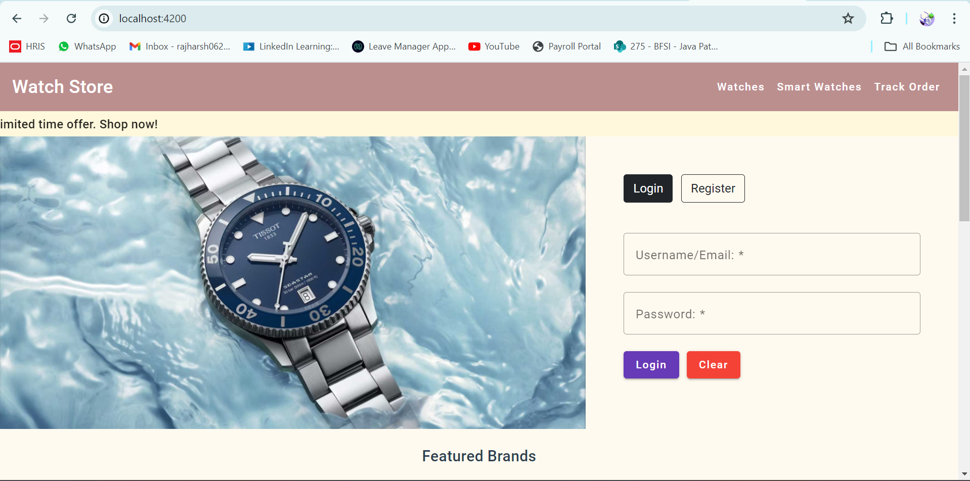

1. Registration Dialog:

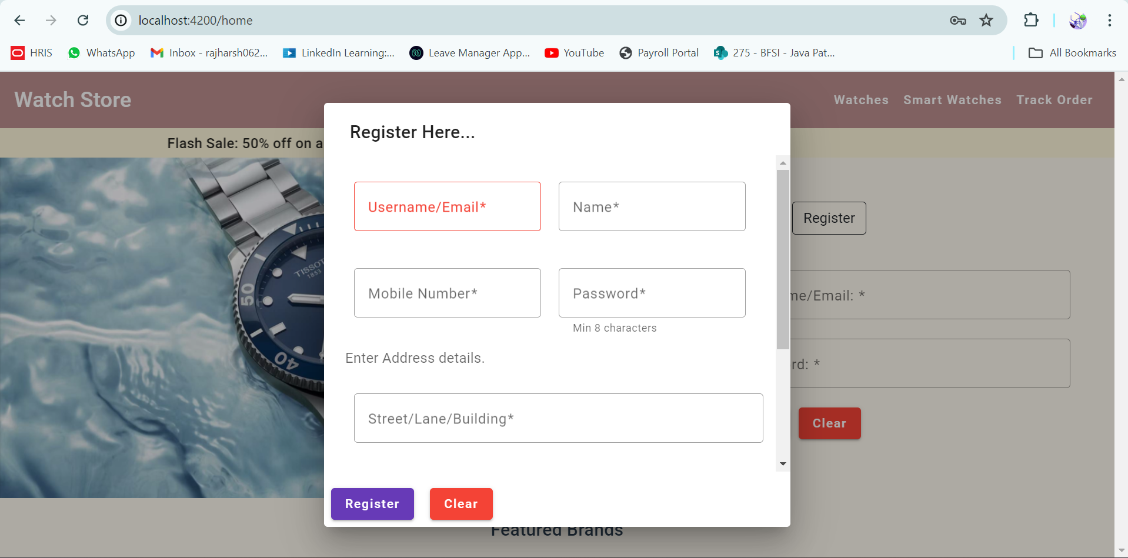

1. User-Dashboard:

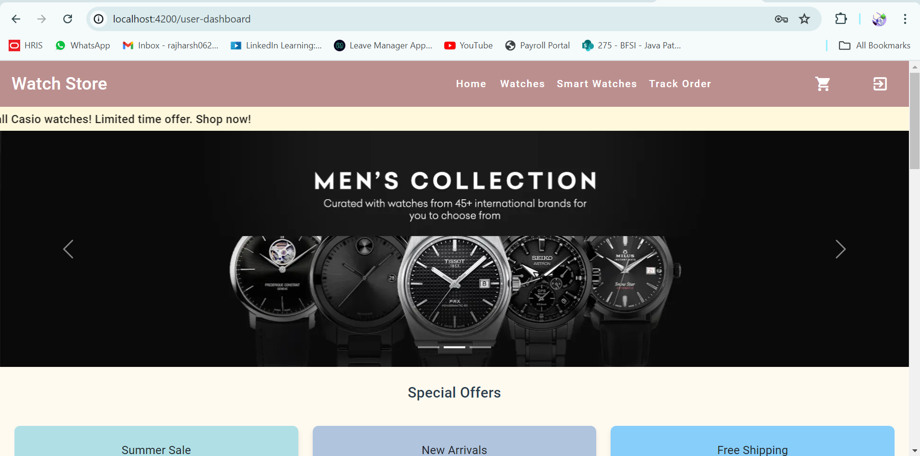

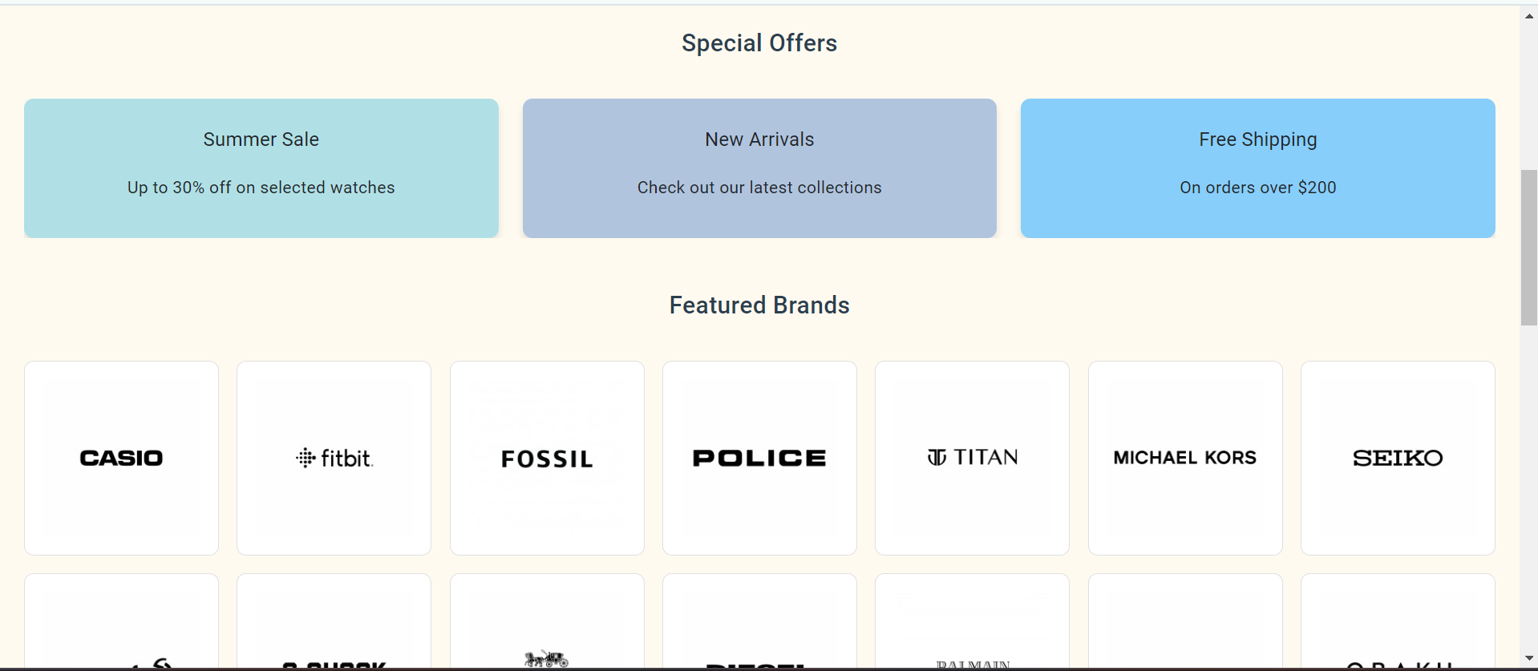

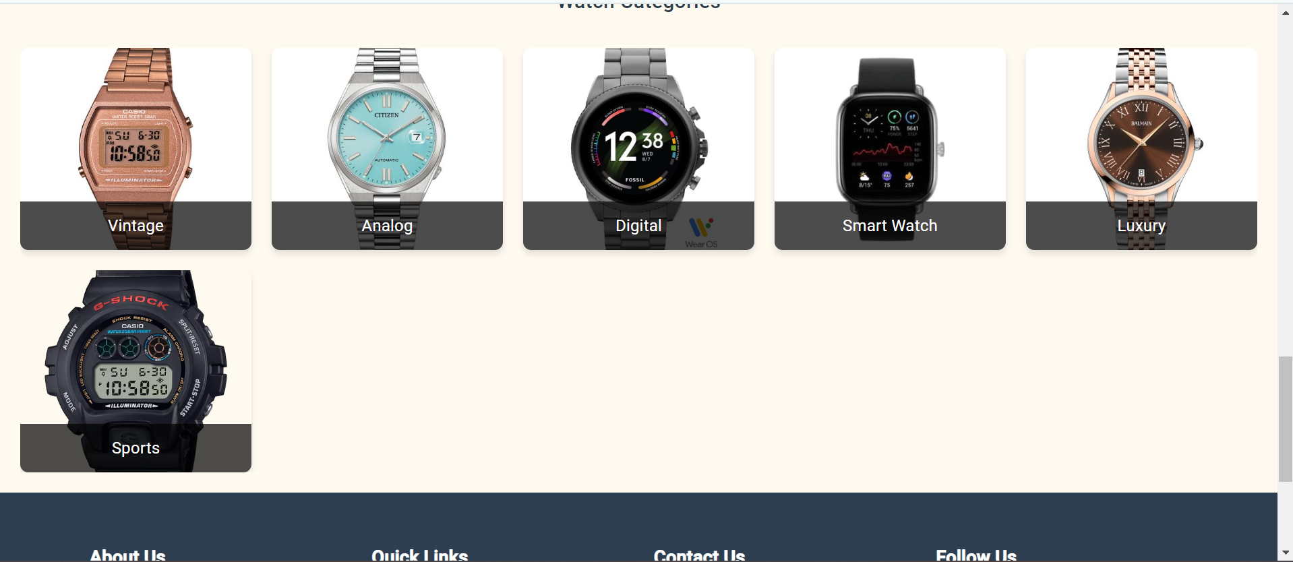

1. All Watches Page:

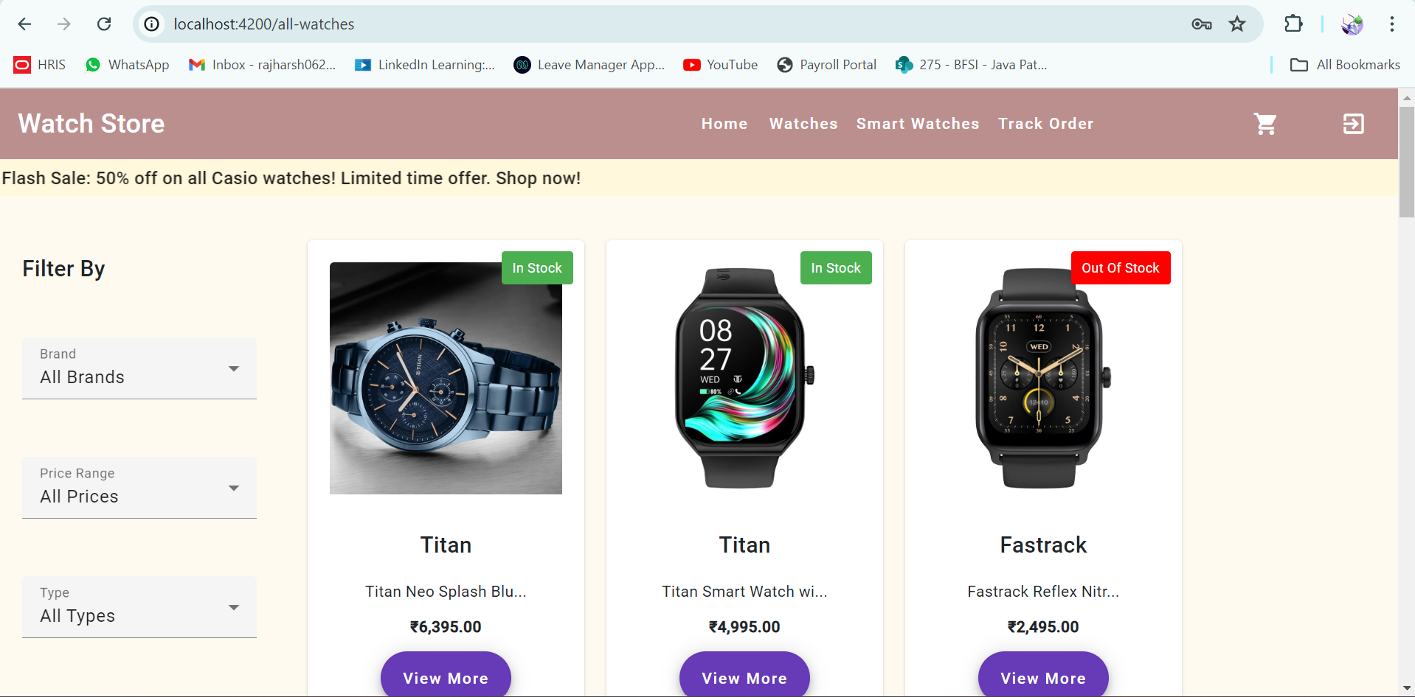

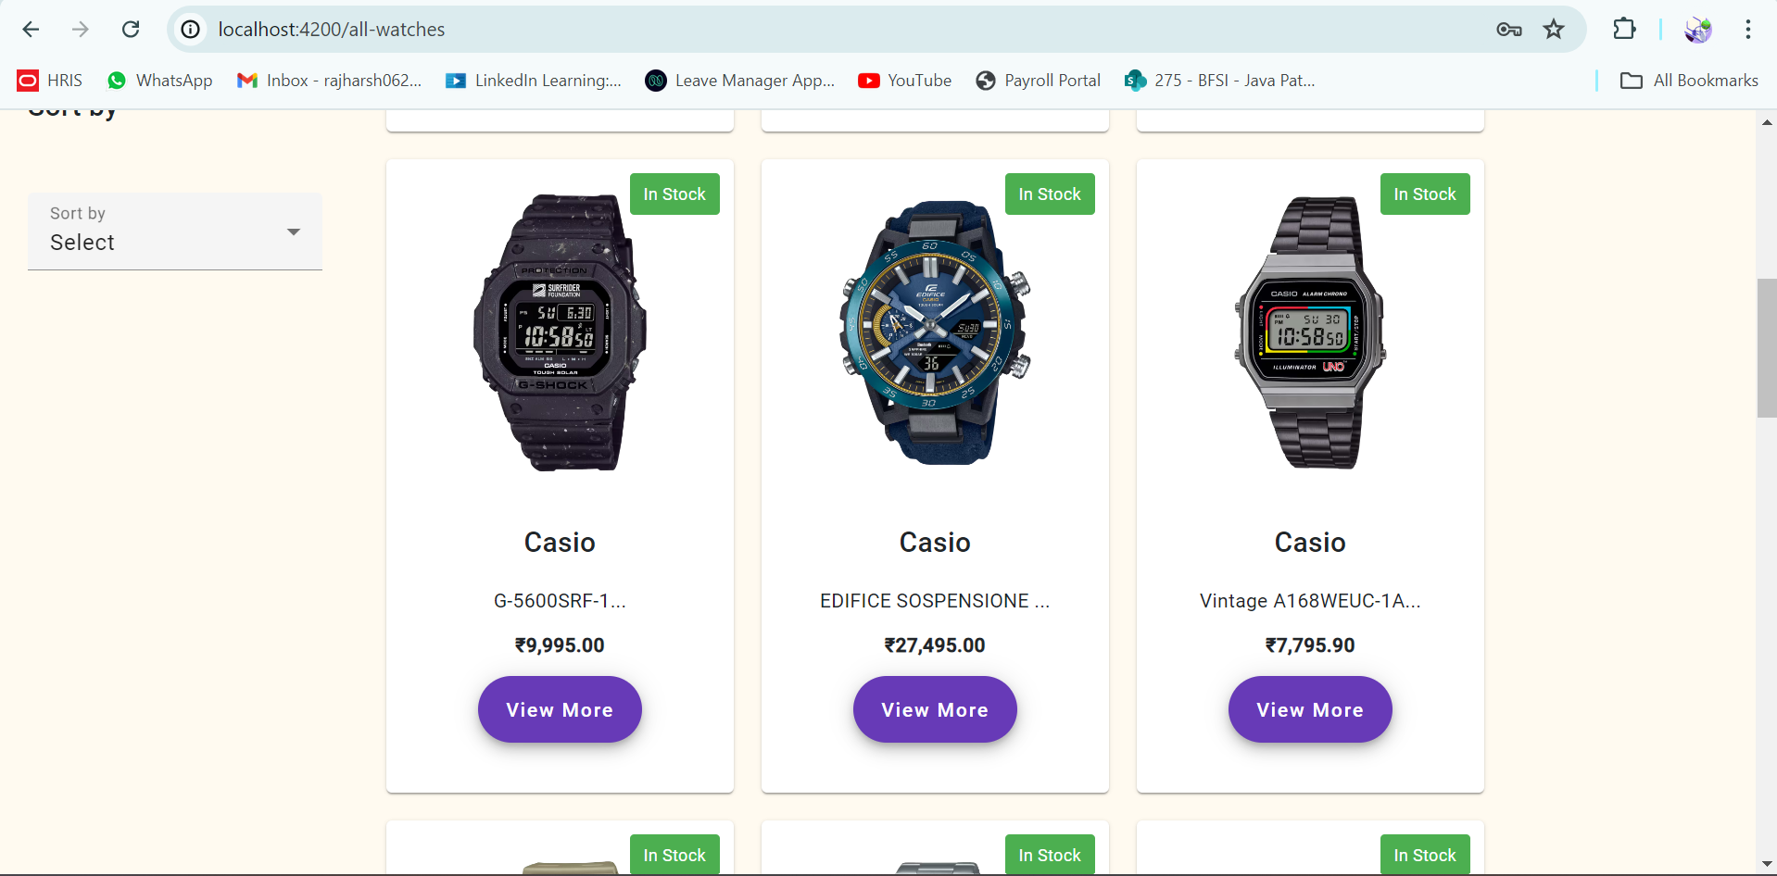

1. View a Single Watch:

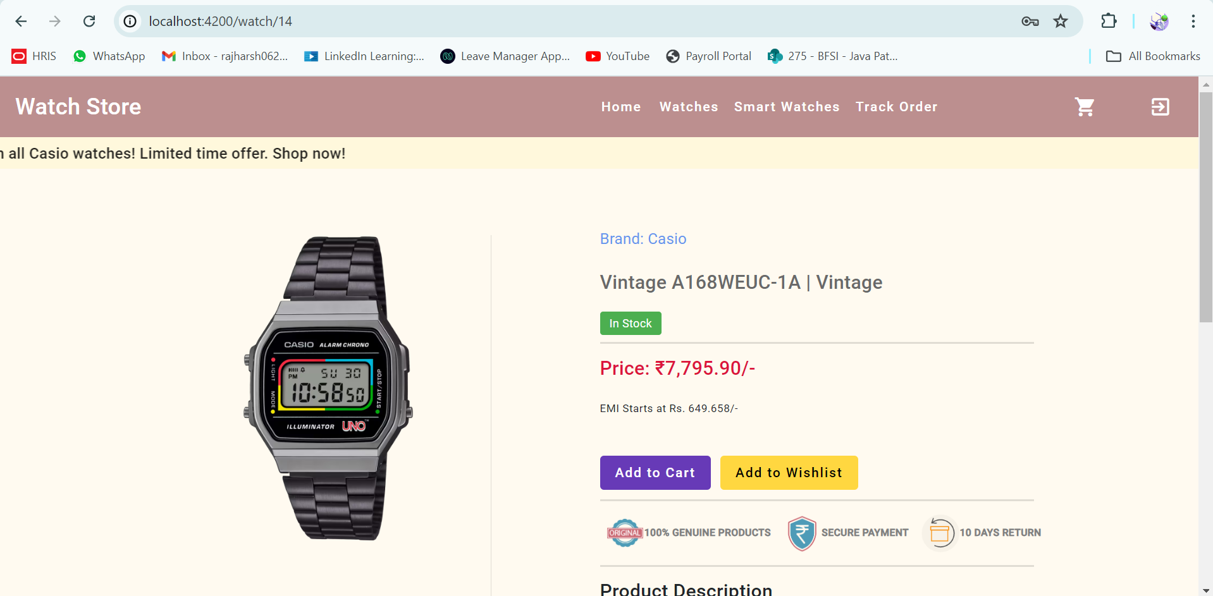

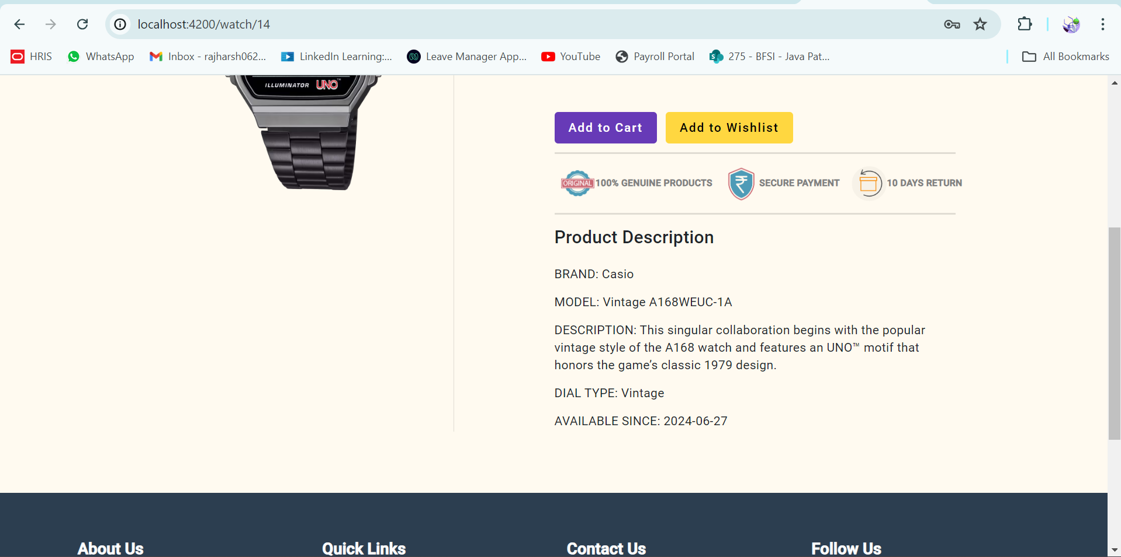

1. User Cart Window:

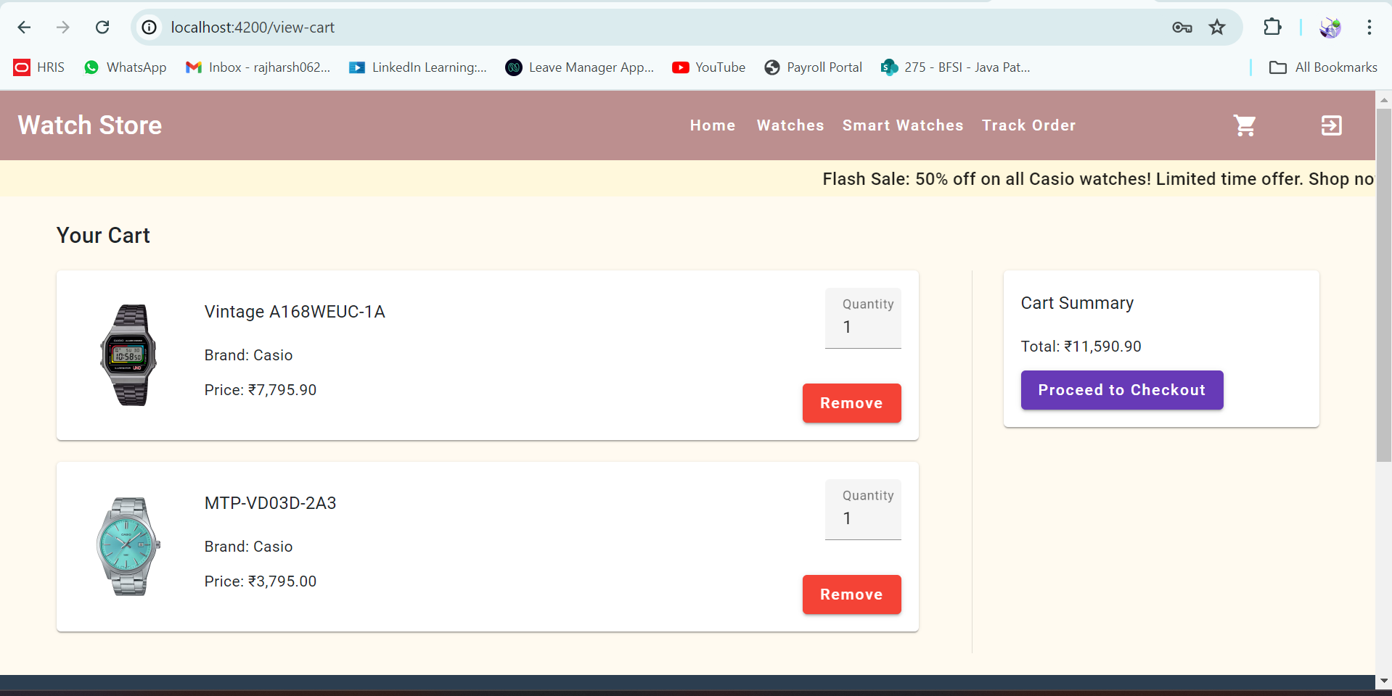

1. Order Checkout Page:

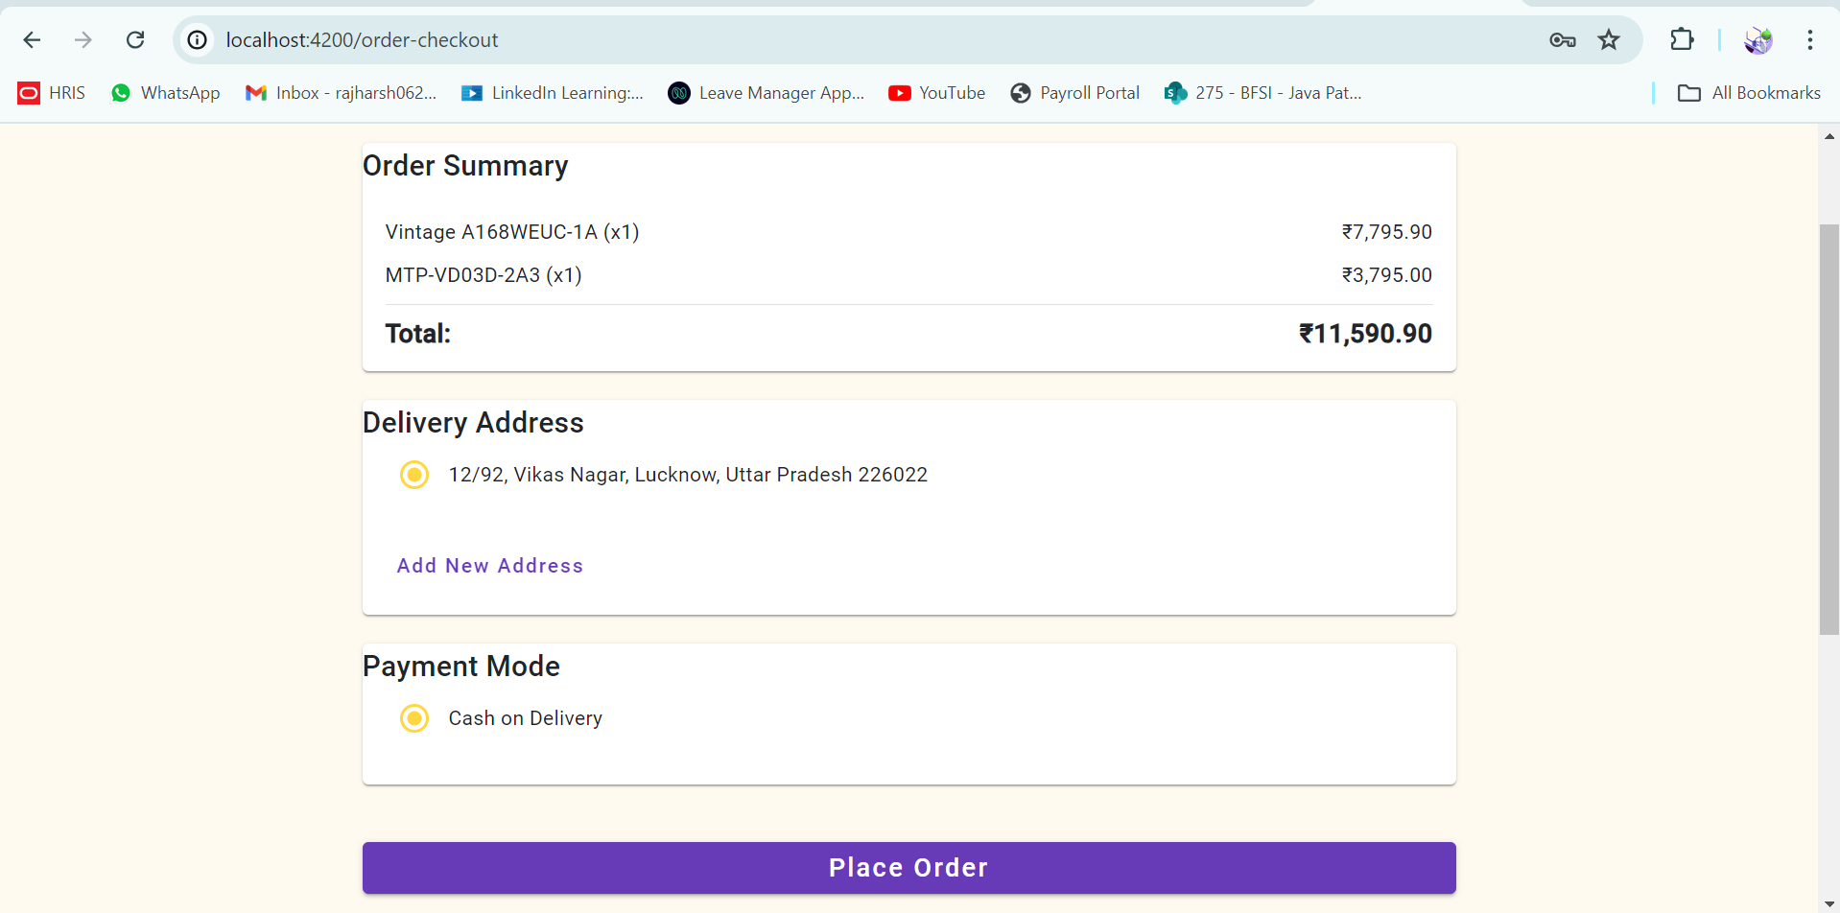

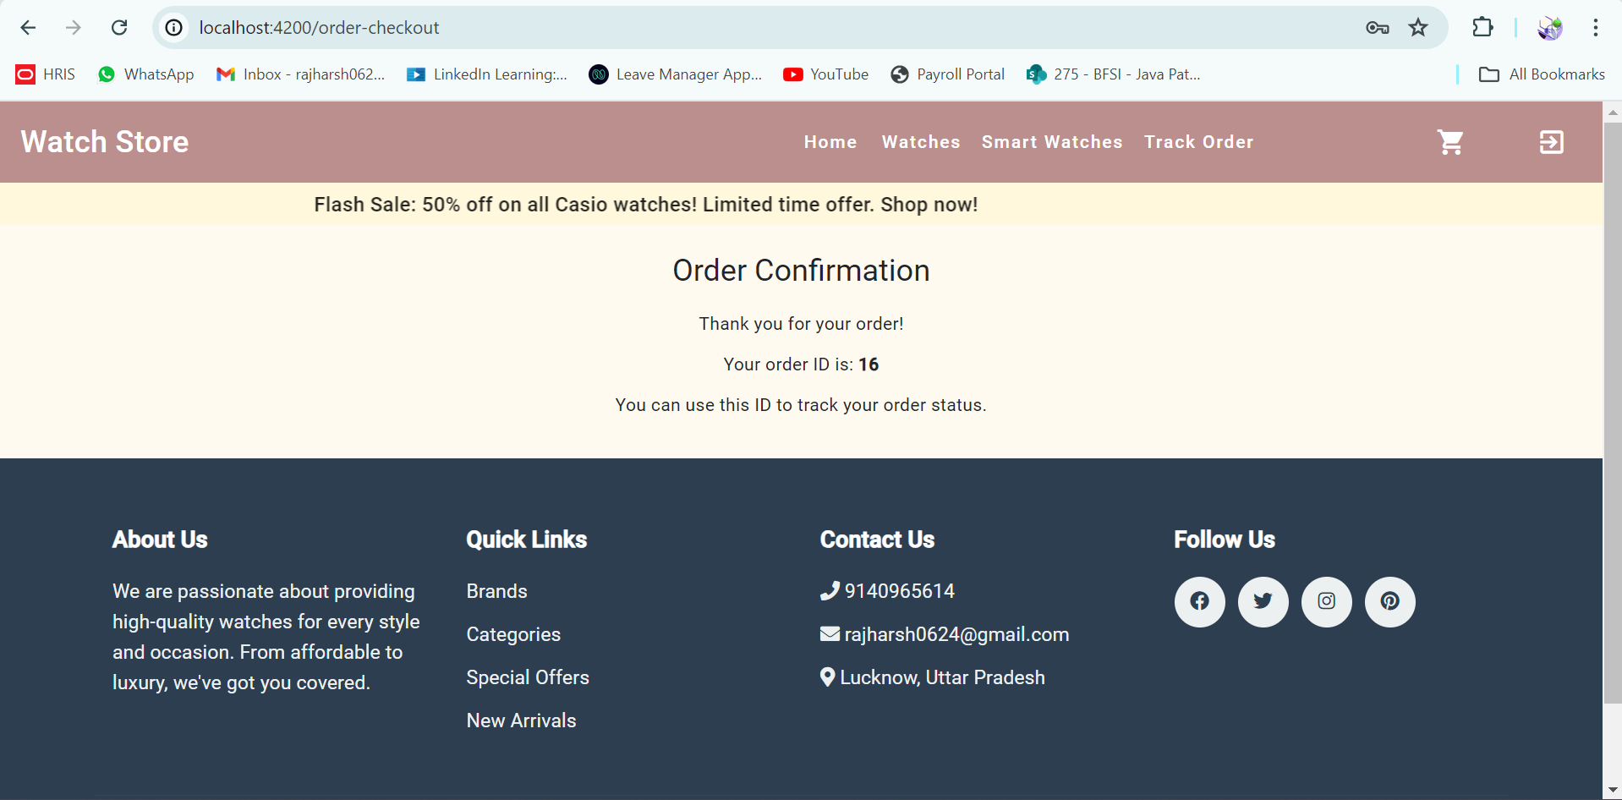

1. Track Order:

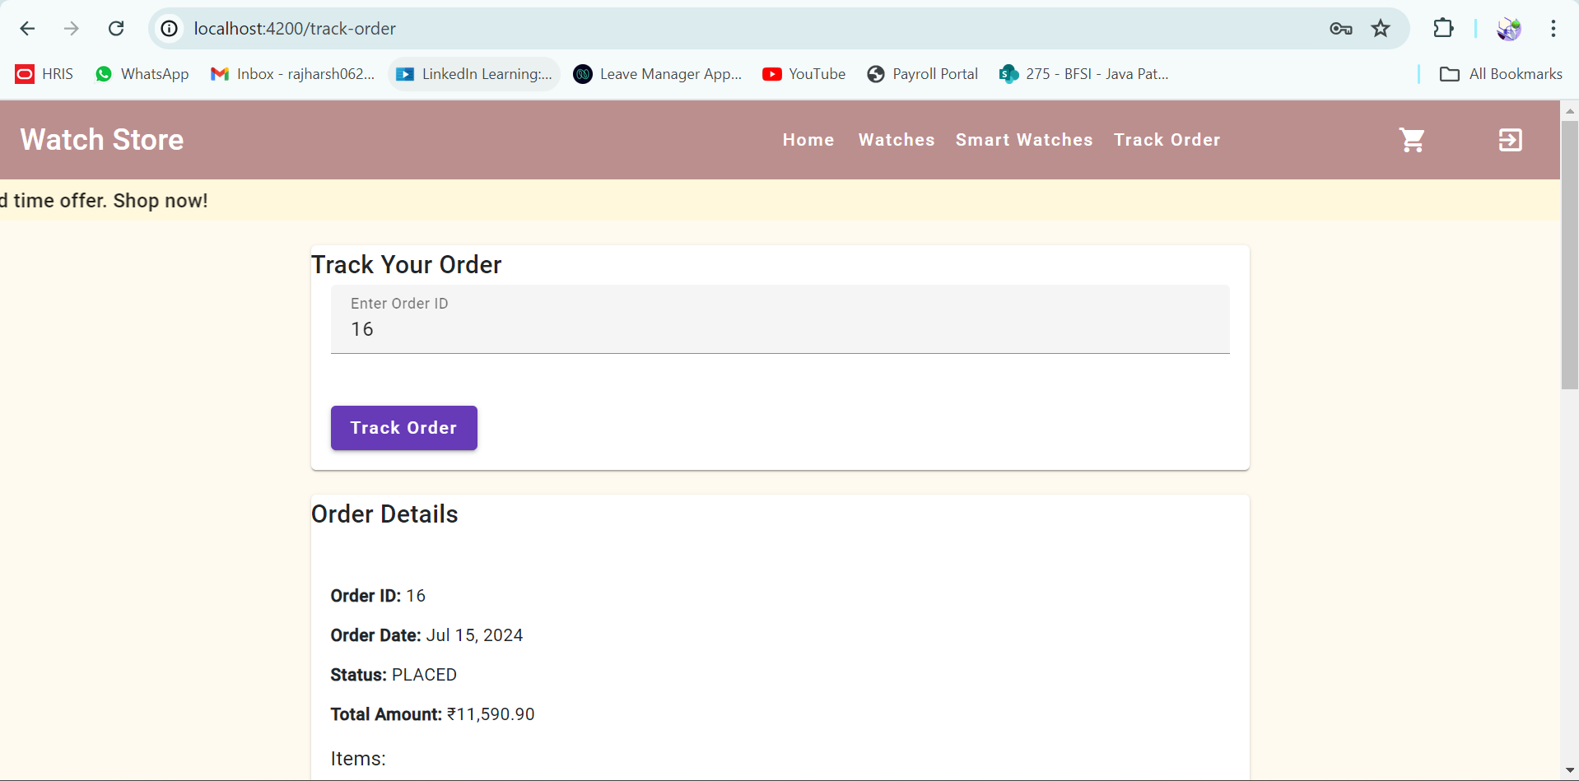

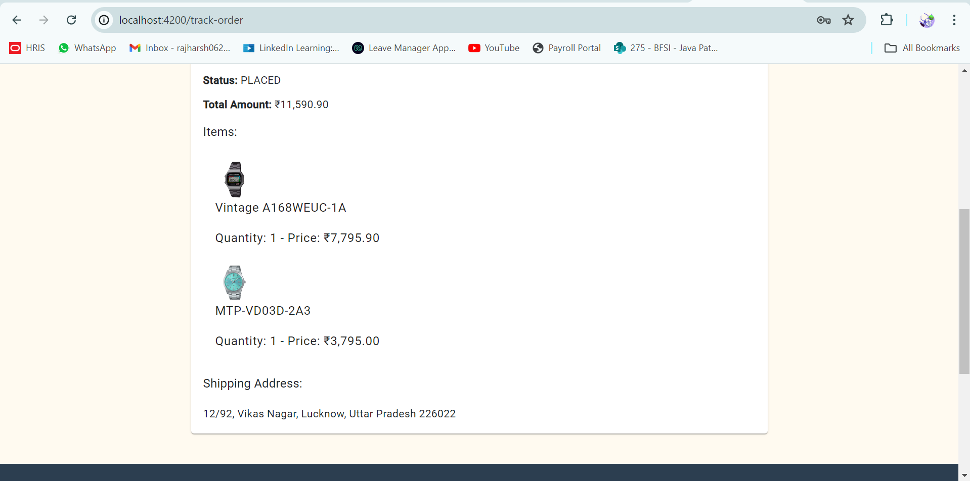

1. Admin Dashboard:

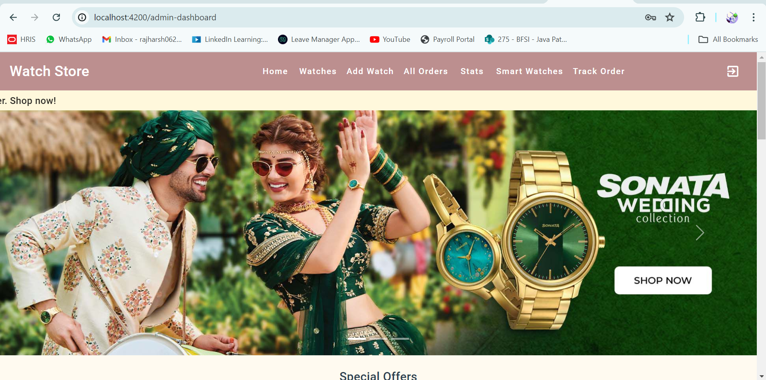

1. Add-Watch Dialog:

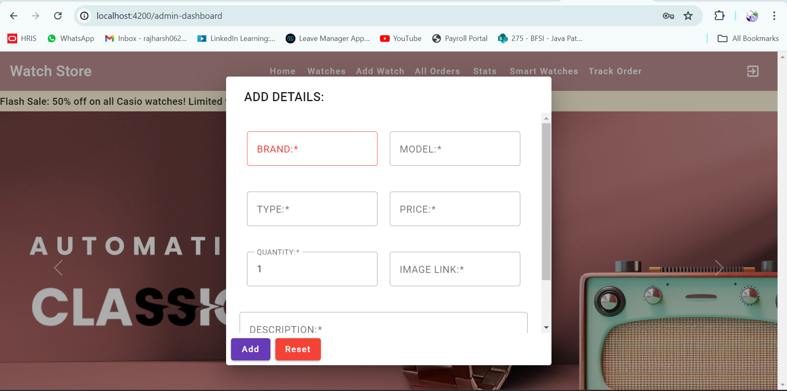

1. Update-Watch Dialog:

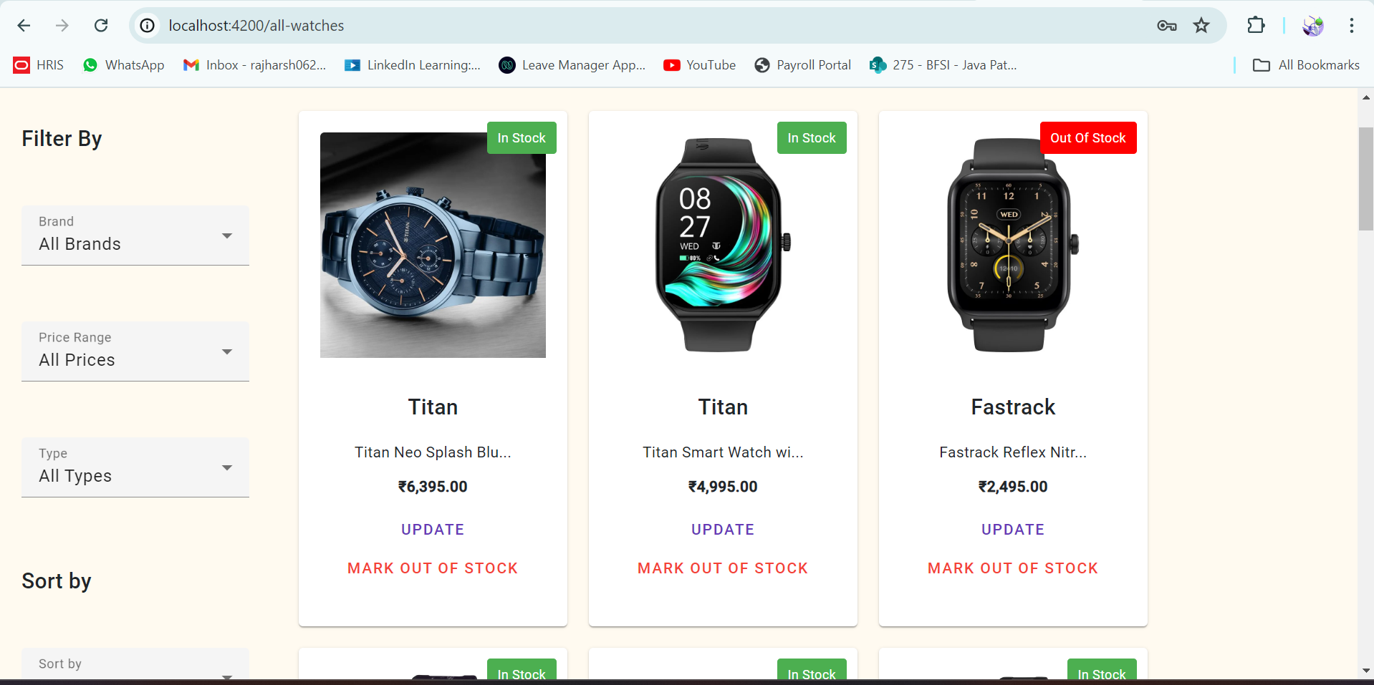

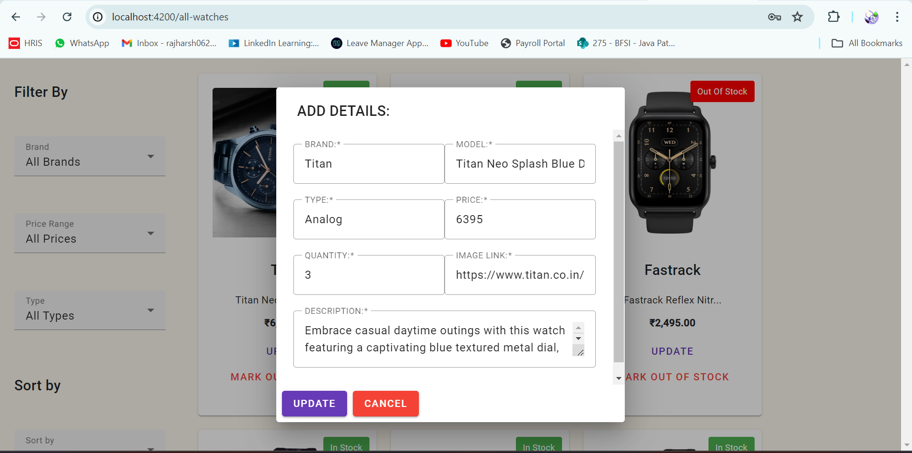

1. All-Orders Window:

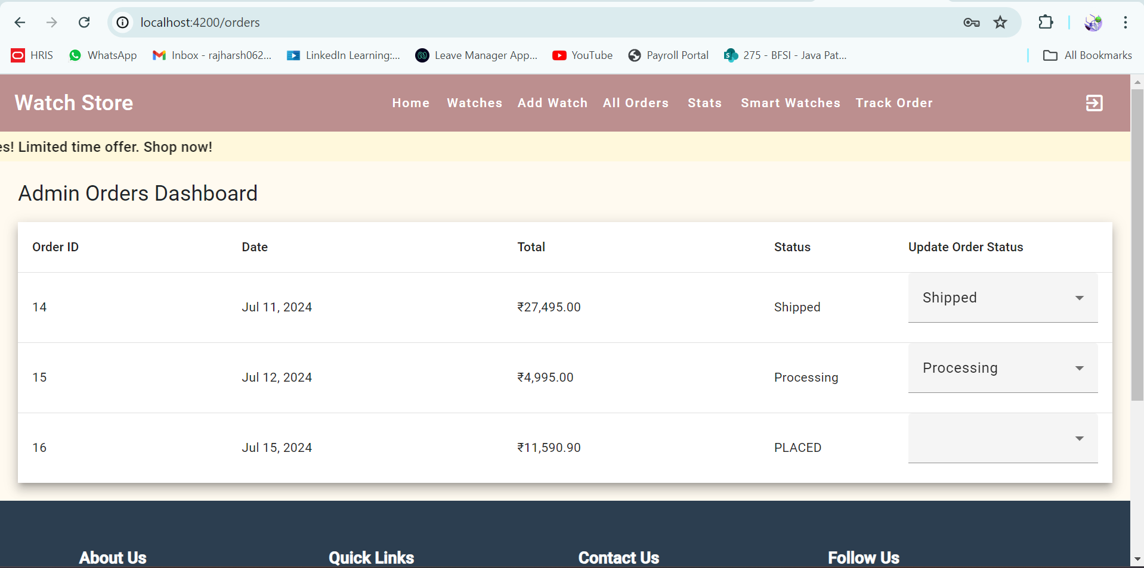

1. Stock Status Chart:

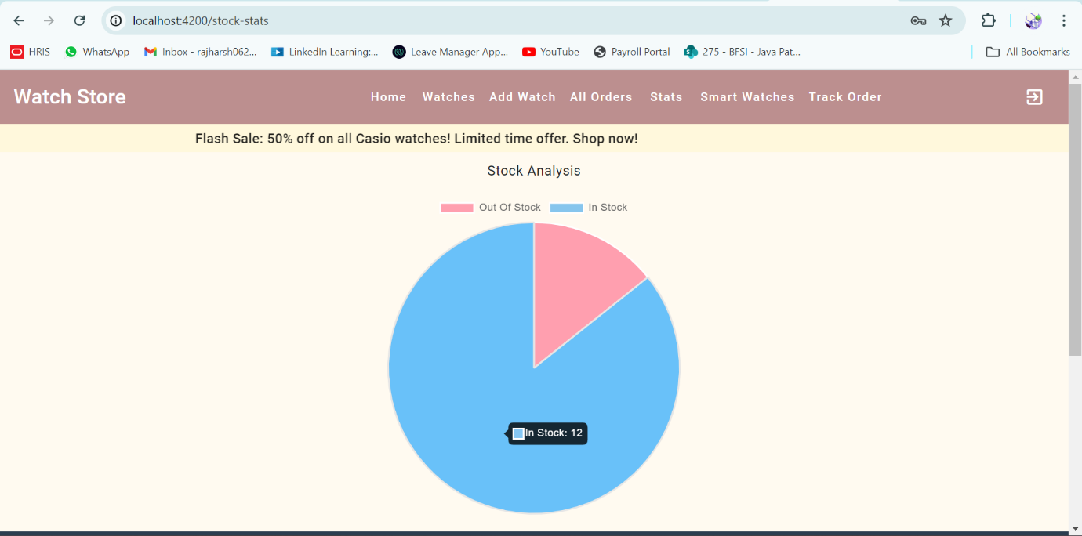

1. Footer:

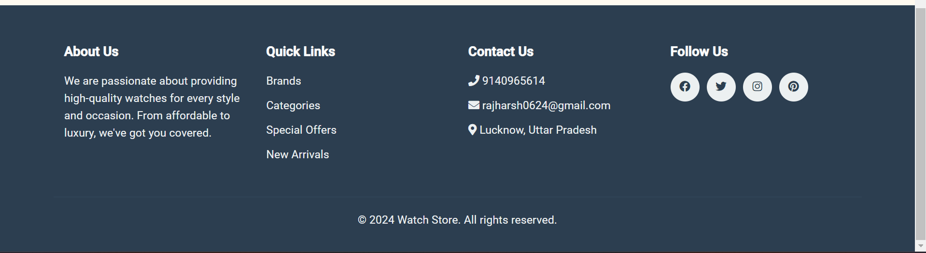

1. Backend Project Structure:

